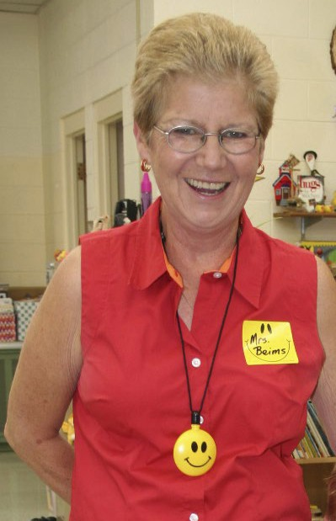

Peach Beims Memorial Scholarship
Peach loved learning, dedicating her life to education. Hundreds of children began their educational
journey in her kindergarten classrooms, and due to her unique style and obvious passion, many acquired that same love of learning. Due to her goofy personality, her quirky classrooms and her obvious
enthusiasm for teaching, many consider Mrs. Beims among their
favorite teachers. She enjoyed watching former students excel
as they grew. She often continued to help them along the way
any way she could. Staying true to her love of students and
helping others we offer this Scholarship in her beautiful memory.
Two scholarships are available to all current seniors of Rawlins
County High School who are planning to attend a community
college, Vocational-technical school, or a four- year college or
university. The application is to be typed and kept to one page.
Scholarship based on character and initiative. Strong
consideration will be given to students interested in careers involving education or working with children.
Deadline: April 15th at 4:00 pm to the high school office
Attach: Resume, transcript & essay questions to this application

Applicant name and permanent address: __________________________________________________
_____________________________________________________________________________________
_____________________________________________________________________________________
What college or university are you planning to attend? ________________________________________ What is your planned area of study? _______________________________________________________ Address of Finance Office that will receive the scholarship check?
_____________________________________________________________________________________
Student ID #: __________________________________________________________________________
Retype each question and then respond---one-page limit.
1. Please tell us your favorite teacher (past or present) and why they hold that honor.
2. Please tell us your favorite childhood book and why.

